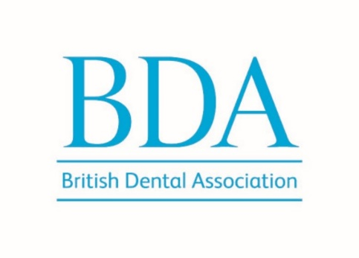

Sponsorship of a BDA Branch or Section event

Why sponsor a BDA local event?

The British Dental Association are a respected provider of high quality CPD events, which attract practising and proactive dentists with a desire to learn and improve their practice. We very much appreciate your support, which helps us support dentists.

We can offer you:

Prestige and branding opportunities
- Announcement at the opening of the event thanking you for your support
- Inclusion of your company logo on the Welcome slides, shown at the beginning of the event

Promotion of the session
- Company logo on the web page for the event
- Hyperlink from the BDA event web page to the sponsor’s website
- Company logo included on a post promoting the event on the Branch Facebook group

Exhibition stand
- Space for a tabletop stand at the event to display your products or literature
- Up to two staff to meet and talk with delegates
- Clothed trestle table and two chairs provided

Delegate data
- A question included in the online Feedback survey post event and the names and email addresses provided to you for anyone who responds “Yes”.
Would you like to receive further information by email from XXX about their products and services?

Your commitment will provide:

Direct access to dental professionals
BDA local events attract decision-makers, including practice owners, associate dentists, specialists and depending on the topic some DCPs. Sponsors gain face-to-face access to individuals who influence purchasing decisions in their practices.

Brand visibility and credibility
Aligning with the BDA, the largest membership body for dentists in the UK, enhances a company’s reputation. The BDA is a trusted and respected organisation, and sponsorship signals a commitment to supporting the profession.

Local engagement and relationship building
These events are community-focused, allowing sponsors / your local representatives to build meaningful relationships with local dental professionals. This grassroots engagement can lead to long-term partnerships and customer loyalty.

Product and service promotion
Sponsors can showcase their offerings through an exhibition stand – it’s a chance to educate attendees about new technologies, services, or innovations in a relaxed and receptive setting.

Market insights
Engaging with attendees provides feedback and insights into current challenges, trends, and needs within the dental sector.

Cost-effective marketing
The BDA’s local events offer an affordable sponsorship option while still delivering one-to-one engagement.

Support for continuing professional development (CPD)
Sponsors supporting local CPD initiatives are seen as contributing to the professional growth of dental practitioners, which enhances goodwill and brand association.

