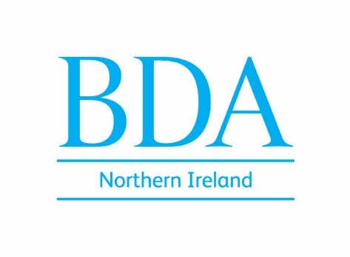

To: Colin Mackenzie, GDC Head of Nations and Engagement
Tom Whiting, Chief Executive Officer;
Donald Burden, GDC Council;
General Dental Council
37 Wimpole Street
London
W1G 8DQ

28th July 2025

Re. GDC Roundtable event 24 July -Northern Ireland

Dear Colin/Tom/Donald

On behalf of the BDA Northern Ireland delegation and NI Council, I wanted to pass on our thanks for taking the time to engage directly and in-person with representatives of the dental profession in the context of the GDC’s new Corporate Strategy.

As our contributions testified, this is a time of immense challenge for our local dental workforce. From significant workforce pressures, not least recruitment and retention of staff working in CDS and HDS, to the seismic shift away from Health Service dentistry resulting from contract failure in GDS, alongside navigating new challenges such as those emerging from dental tourism, our profession has much to contend with.

We believe this challenging context underscores the importance of proactive leadership, and a shift towards a strongly supportive stance on behalf of registrants and the valuable services they provide by their professional regulator. As such, we welcome GDC’s publicly stated commitment to, ‘adopting more supportive approaches to regulation’, ‘building trust’ and ‘moving away from a climate of fear’.

For our part, BDA NI has always sought to be part of the solution, calling out issues where we see them but always willing to work constructively with those statutory bodies committed to effecting positive change. Dental system reform in Northern Ireland is imperative, incorporating those key components of proper workforce planning and a contract model which stabilises the GDS and can meet the oral health needs of our entire population.
It’s vital, therefore that last week’s roundtable marks the beginning of a new approach, one which deepens engagement in Northern Ireland, and which meaningfully seeks to address the pressing needs and challenges of local registrants and dental services.
In the context of the GDC’s new corporate strategy, we consider there is an important role for the GDC to play in supporting registrants by seeking to advance areas of reform required at a system-wide level.

As the representative body of dentists in Northern Ireland, BDA Northern Ireland would very much welcome the opportunity to engage with our professional regulator on a more routine basis, perhaps using a future meeting of Northern Ireland Council as the vehicle for this.
We are committed to performing our role in ensuring that the particular issues impacting on dentists practising in Northern Ireland are fully understood, and as such, we look forward to informing the work of GDC going forward.

We look forward to future opportunities to develop these important conversations.

Yours sincerely
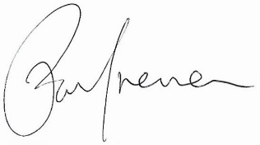

Paul Brennan
Chair, BDA Northern Ireland Council

